**Pricing Model for a Smartwatch Company**

**Business Analyst @ Analytics**

**Overview**

They manufacture their own products but procure raw materials from other companies since they can't afford to build their own research and development department at present.

**Situation**

NuWave wants to launch a new smartwatch, which will be one of their flagship products. They plan to launch the watch with an OLED display.

They intend to first enter the market and gain at least 5% of the market share.

As a new player in the smartwatch market, they want to price the watch **lower**than their competition (selling at ₹ 7,799).

The **demand**in such a market is **elastic**, meaning a small price change can cause a significant change in demand.

To achieve 5% of the market share, NuWave needs to sell at least**1,800 units per day.** Assume NuWave can completely fulfill the demand for the day.

**Complication**

For NuWave to sell 1,800 smartwatches a day, they need to have a certain level of inventory.

Each smartwatch requires one OLED panel. For smooth production, they need to have its stock as well.

NuWave can store only 2000 OLED panels in their own facility. To store more, they need a warehouse, which will cost them ₹ 12,000/day. They can store 10,000 OLED panel units in one warehouse.

The warehouse should not be underutilized.

Now, as a business analyst at NuWave, your job is to find out:

1. At what price should they sell one unit, to gain a 5% market share and earn at least a 2% profit margin?
2. Minimum order quantity of panels at that price point so NuWave doesn't make a loss.

**Key Expectations**

Build a spreadsheet model to find out the selling price of one smartwatch so that:

1. NuWave can gain a 5% market share.
2. Earn at least a 2% profit margin.

**First Submission**

Hey there! Before we start with the actual problem, try solving a mini version of the problem here. It will boost your confidence and clear some concept.

|  |  |
| --- | --- |
| **Quantity** | **Per Unit Cost** |
| 1 | ₹ 1,750 |
| 1000 | ₹ 1,575 |

The price of panels depends **linearly**on the number of units ordered. The higher the quantity order, the lower the per-unit cost.

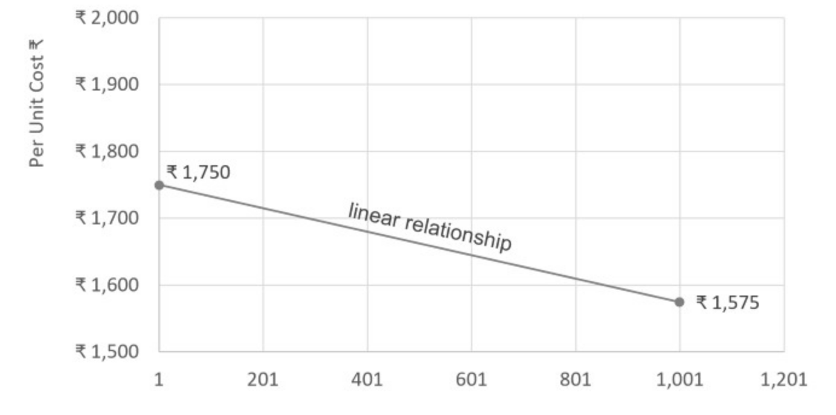

With the above information, answer the questions in the Skill Validation tab.

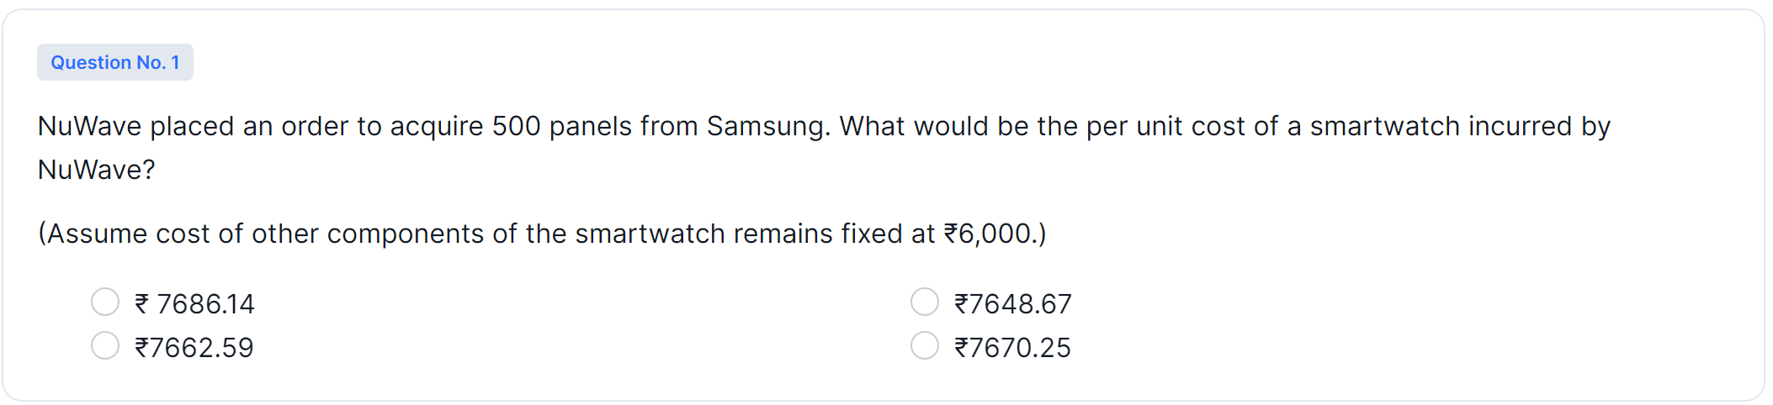

Based on your understanding in this objective, answer the below question and validate your work.

Here we have to use linear relationship to find the per unit cost of a smartwatch incurred by NuWave.

A linear relationship is a fundamental concept in mathematics and statistics that describes a straight-line relationship between two variables. In a linear relationship, as one variable changes, the other variable changes proportionally in a consistent manner. This relationship is often represented by a linear equation or a straight-line graph.

Equation Form:

The general form of a linear equation is:

y = mx + b

"y" is the dependent variable.

"x" is the independent variable.

"m" is the slope of the line, representing the rate at which "y" changes with respect to changes in "x."

"b" is the y-intercept, which is the value of "y" when "x" is zero. It's the point where the line crosses the y-axis.

Slope: The slope of the line indicates the rate of change between the variables. It represents how much "y" changes for a unit change in "x." A positive slope means that as "x" increases, "y" also increases, while a negative slope means that as "x" increases, "y" decreases.

Y-Intercept: The y-intercept is the point where the line crosses the y-axis. It gives the value of "y" when "x" is zero. In other words, it's the initial value of the dependent variable "y" before any changes in the independent variable "x."

Here the price of panels depends **linearly**on the number of units ordered. The higher the quantity order, the lower the per-unit cost.

Here y is the per unit cost and x is the order quantity. When the order quantity increases the per unit cost decreases, or the value of slope(m) would be negative.

Negative Slope (m < 0): When the value of "m" is negative, it indicates that as the independent variable "x" increases, the dependent variable "y" decreases. This is a negative correlation between the variables. For instance, as the temperature (x) increases, the demand for winter clothing (y) might decrease.

In this context, a linear relationship refers to the correlation between two variables (in this case, quantity and cost) that can be described by a straight-line equation. When you plot the data points on a graph, they form a straight line, hence the term "linear."

In summary, the linear relationship is established using the slope formula to determine the cost decrease rate with increasing quantity. Then, the point-slope formula helps calculate the specific cost for a given quantity. Finally, the total cost is computed by adding the cost of OLED panels and the fixed component cost.

Let's break down the steps used to establish and utilize the linear relationship between the quantity of OLED panels ordered and the per unit cost:

Step 1: Data Points

The given information provides two data points:

Quantity: 1, Per Unit Cost: ₹1,750

Quantity: 1000, Per Unit Cost: ₹1,575

These points represent the quantity of panels ordered and their respective per unit costs.

Step 2: Calculate the Slope

The slope of the line (m) represents the rate of change of the cost with respect to the quantity. It can be calculated using the formula:

Slope (m) = (Change in Y) / (Change in X) = (Cost at Quantity 2 - Cost at Quantity 1) / (Quantity 2 - Quantity 1)

Substituting the values:

Slope (m) = (₹1,575 - ₹1,750) / (1000 - 1)

= ₹-175 / 999

≈ -₹0.175

The negative slope indicates that as the quantity increases, the cost decreases.

Step 3: Using the Point-Slope Formula

The point-slope formula of a linear equation is:

y - y1 = m(x - x1)

Here, y represents the cost, x represents the quantity, (x1, y1) is one of the given data points.

Using the first data point (1, ₹1,750):

Cost - ₹1,750 = -₹0.175 * (Quantity - 1)

Step 4: Calculate the Cost

Now, substitute the quantity of 500 units into the equation:

Cost - ₹1,750 = -₹0.175 * (500 - 1)

Cost - ₹1,750 = -₹0.175 * 499

Cost = ₹1,750 - ₹87.325

Cost ≈ ₹1,662.675

Step 5: Total Cost

Since the cost of other components of the smartwatch remains fixed at ₹6,000, you simply add this fixed cost to the calculated cost of the OLED panels:

Total Cost = Cost of OLED panels + Cost of other components

Total Cost = ₹1,662.675 + ₹6,000

Total Cost ≈ ₹7,662.675

Rounding to two decimal places, you get ₹7662.59, which is the closest option to the calculated value.

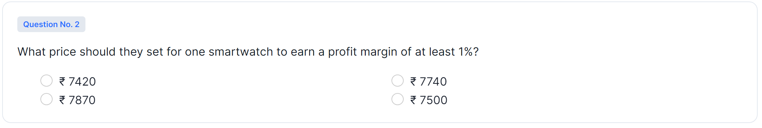

To calculate the price NuWave should set for one smartwatch in order to earn a profit margin of at least 1%, we need to consider the cost of production and the desired profit margin.

From the previous calculations, we know that the cost of producing one smartwatch (including OLED panels and other components) is approximately ₹7,662.59.

To calculate the selling price with a profit margin of 1%, we need to add 1% of the cost to the cost itself:

Profit Margin = 1% = 0.01

Desired Selling Price = Cost + (Cost * Profit Margin)

Desired Selling Price = ₹7,662.59 + (₹7,662.59 * 0.01)

Desired Selling Price = ₹7,662.59 + ₹76.6259

Desired Selling Price ≈ ₹7740.2159

Rounded to two decimal places, the closest option is ₹7740. Therefore, the correct answer is: ₹7740

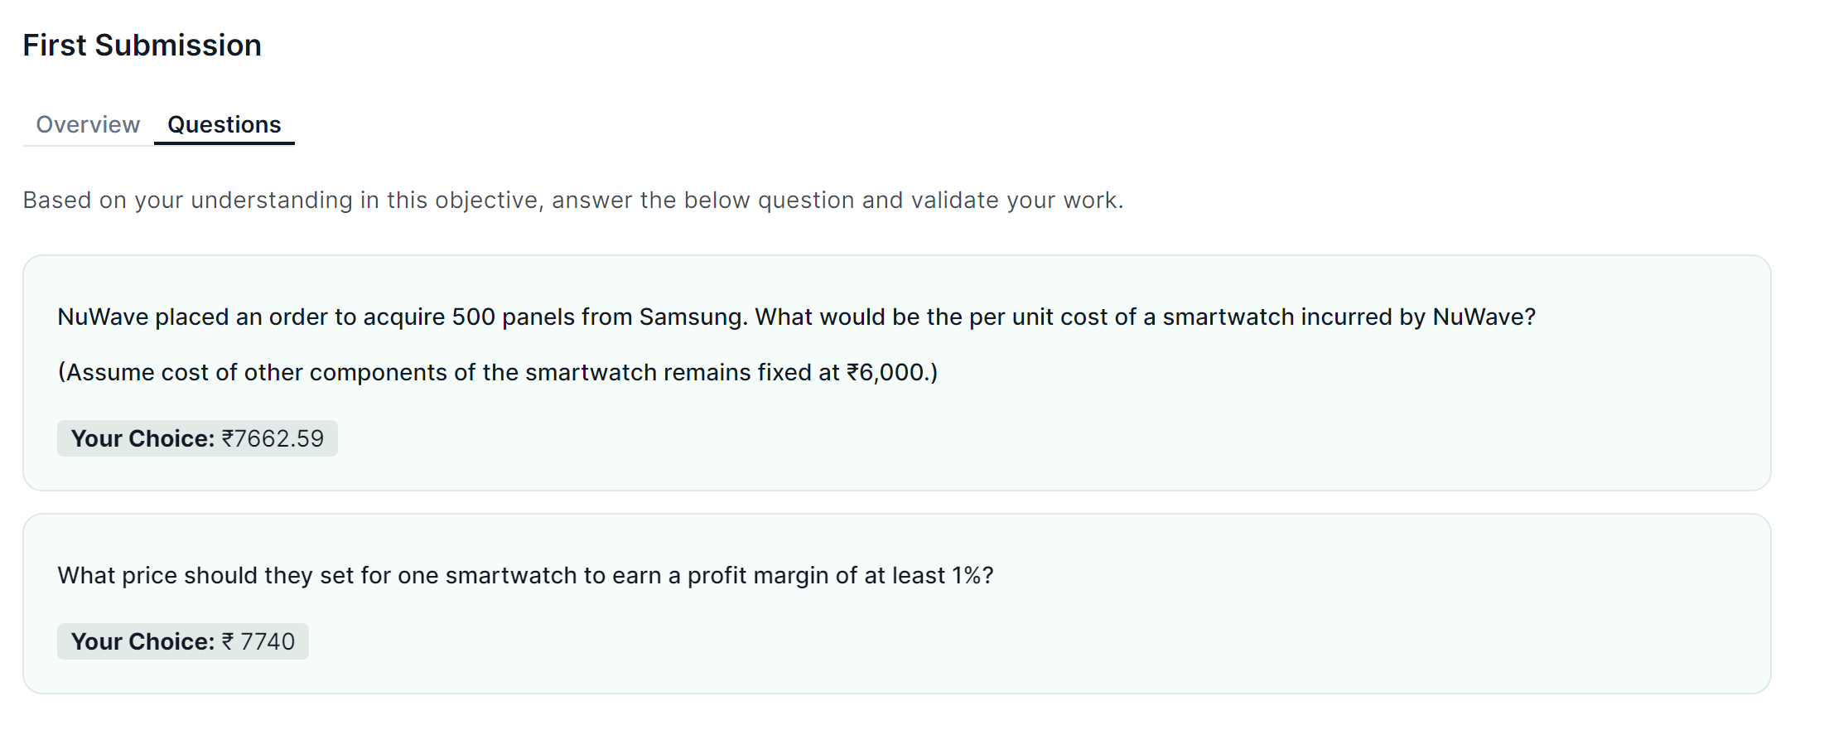

**Finding Cost per Unit**

**Overview**

✅ Great job on solving the mini case! Now, let's get back to our main problem.

**How NuWave Can Control Cost**

To calculate the selling price of one smartwatch, we need to know its cost. Also, NuWave should be able to generate a profit margin of at least 2%. We know,

Profit = Selling Price - Cost

In the above equation, we can control the cost to some degree.

Why some, you might ask? It depends on the suppliers' rates (Samsung is one of them).

How can NuWave control costs? By changing the order quantity.

You see, in Samsung's quote (given below), the price is changing depending on the order quantity.

|  |  |
| --- | --- |
| **Order Quantity** | **Panel Cost/Unit** |
| 1 | ₹ 1,475 |
| 5000 | ₹ 1,425 |
| 20000 | ₹ 1,250 |
| 50000 | ₹ 450 (lower limit) |

Now NuWave can store only 12,000 units (2,000 in their facility and 10,000 in the warehouse).

What would the unit cost be if they ordered 10,000 units? From the above quote, we can tell it will be between ₹ 1,250 and ₹ 1,425.

But we need to know the exact cost. To do that, we need to model the relationship between order quantity and price.

Modeling Relationship Between Order Quantity (Supply) and Price

Now, looking at Samsung's quote, the relationship would appear to you as non-linear (which it might actually be!).

To keep things simple, assume the relationship to be piecewise linear (multiple straight lines).

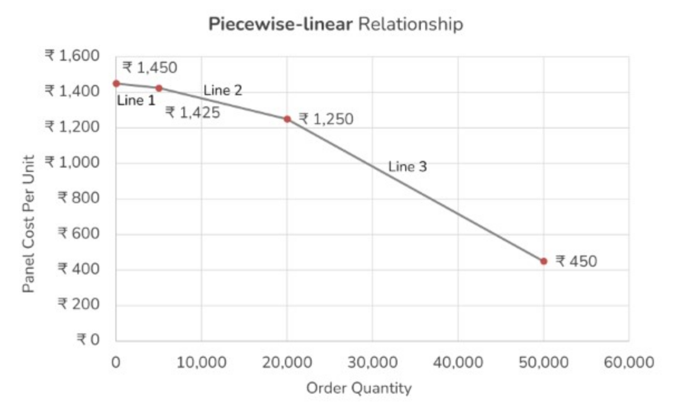

For this milestone, your job is to **create an equation that outputs the cost per unit for a given order quantity**, as per Samsung's quote.

You can create three equations for each line. Depending on the order quantity, you can switch which line should be used to calculate the per-unit cost. The image below shows the slope & intercept of the first line.

Check out the Cost-Supply sheet.

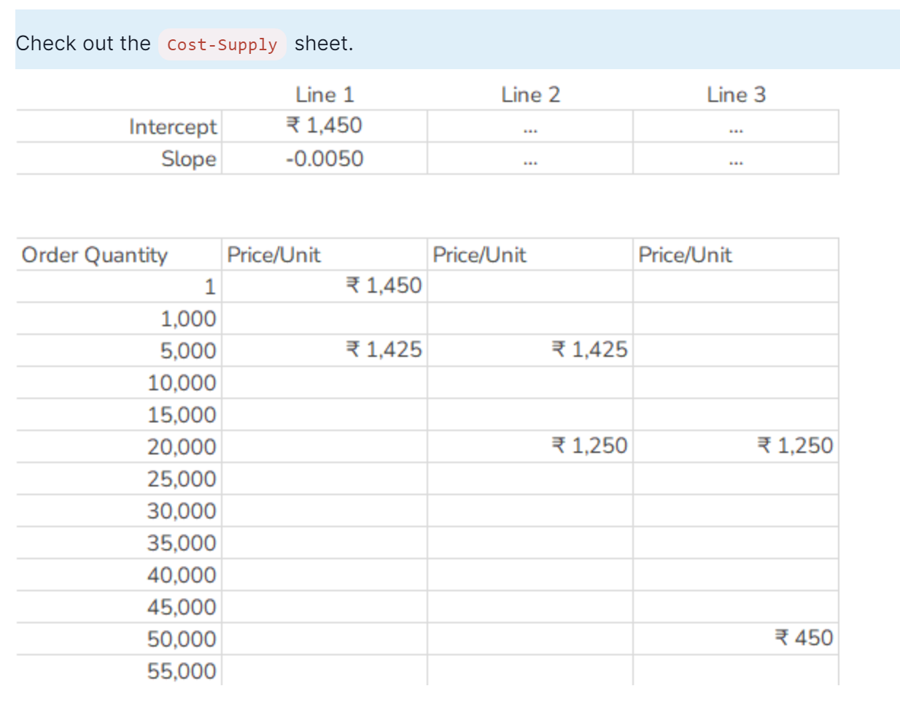

From the provided information, we have the following data points:

Quantity: 1, Panel Cost/Unit: ₹1,475

Quantity: 5000, Panel Cost/Unit: ₹1,425

Quantity: 20000, Panel Cost/Unit: ₹1,250

Quantity: 50000, Panel Cost/Unit: ₹450

Now, we want to create three linear equations, each representing a different portion of the total quantity range. Let's identify the three segments:

For quantities 1 to 5000

For quantities 5001 to 20000

For quantities 20001 to 12000 (maximum quantity NuWave can store)

**Equation for the First Segment (1 to 5000):**

We have two points: (1, ₹1450) and (5000, ₹1425).

Calculate the slope (m) of this segment:

Slope (m) = (Cost at Quantity 2 - Cost at Quantity 1) / (Quantity 2 - Quantity 1)

= (₹1425 - ₹1450) / (5000 - 1)

= -₹25 / 4999

≈ -₹0.0050

Using the point-slope formula:

y-y1 = m(x-x1)

Cost - ₹1450 = -₹0.0050* (Quantity - 1)

Cost of 1000 quantity:

Cost - ₹1450 = -₹0.0050* (1000 - 1)

Cost - ₹1450 =-₹0.0050* 999

Cost ≈ ₹1450 - ₹4.995

Cost ≈ ₹1445.005

Cost of 10000 quantity:

Cost - ₹1475 = -₹0.0050* (10000 - 1)

Cost = 1475 – 49.995

Cost = ₹1425.005

**Equation for the Second Segment (5001 to 20000):**

We have two points: (5000, ₹1425) and (20000, ₹1250).

Calculate the slope (m) of this segment:

Slope (m) = (Cost at Quantity 2 - Cost at Quantity 1) / (Quantity 2 - Quantity 1)

= (₹1250 - ₹1425) / (20000 - 5000)

= -₹175 / 15000

≈ -₹0.01167

Using the point-slope formula:

Cost - ₹1425 = -₹0.01167 * (Quantity - 5000)

Cost of 10000 quantity:

Cost = 1425 + [-0.01167*(10000-5000)]

Cost = 1425 + 58.35

Cost = ₹1366.65

Cost of 15000 quantity:

Cost = 1425 + [-0.01167*(15000-5000)]

Cost = 1425 - 116.7

Cost = ₹1308.3

**Equation for the third Segment (20001 to 50000):**

We have two points: (20000, ₹1250) and (50000, ₹450).

Calculate the slope (m) of this segment:

Slope (m) = (Cost at Quantity 2 - Cost at Quantity 1) / (Quantity 2 - Quantity 1)

Slope (m) =(450-1250)/(50000-20000) = -800/30000

Slope (m) = ≈ -₹0.02667

Cost - ₹1250 = -₹0.02267* (Quantity - 20000)

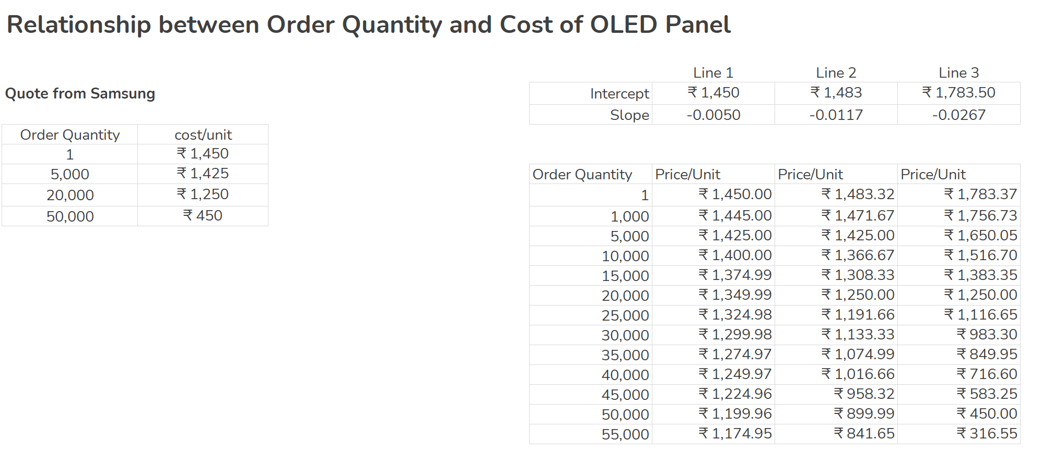

**Calculating Total Cost**

**Overview**

In the previous milestone, we calculated the cost of one smartwatch for different order quantities.

In this milestone, we'll calculate the total cost, including the warehouse storage, for different order quantities.

**Storage Cost**

NuWave can store 2,000 units in their own facility free of charge. To store more units, they will require a warehouse.

The cost of keeping inventory in the warehouse is ₹ 12,000/day. The total number of units that can be stored in the warehouse is 10,000.

So, if NuWave orders 5,000 units of OLED panels, they have to store 3,000 in the warehouse. If they manage to sell 1,800 units/day, they have to store these 3,000 units for 2 days!

Cost of storage for 2 days = 2 * ₹ 12,000 = ₹ 24,000

**Total Cost**

Say the unit cost for ordering 5,000 panels is ₹ 1,000 and other components cost ₹ 6,000,

total cost for 5,000 smartwatches = (₹ 1,000 + ₹ 6,000) * 5,000 = ₹ 3,50,00,000

total cost = ₹ 3,50,00,000 + ₹ 24,000 = ₹ 3,50,24,000

You have to implement the same logics in the Model sheet. Depending on the quantity ordered, calculate the total cost.

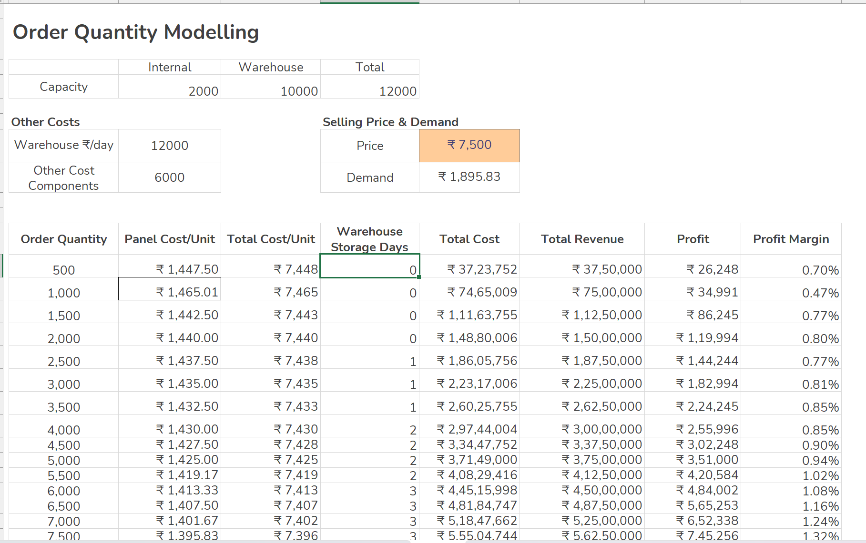

**Calculating Selling Price**

**Overview**

Project Deliverables

Well done up to now! We have calculated the total cost. Let's now find the selling price of one smartwatch.

**Modeling Relationship Between Selling Price and Demand per Day**

During the testing phase, NuWave found out that the demand is fairly elastic.

1. If they sell one smartwatch for 5,000, they can sell 10,500 units a day.
2. When they increased the price to ₹ 8,000, they were only able to sell 175 units a day.

The first thing you need to do is model the relationship between demand per day and selling price in the Price-Demand sheet. Assume **linear relationship.**

NuWave can store 2,000 units in their own facility free of charge. To store more units, they will require a warehouse.

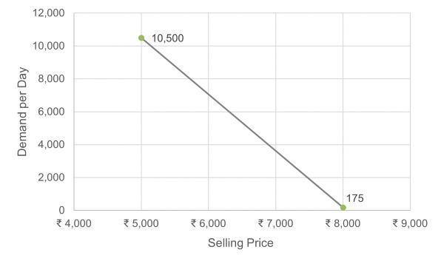

Model the equation such that you can input the selling price and get demand per day as an output.

**Calculating Selling Price**

Assume any selling price and calculate total revenue based on it. After calculating the revenue, you can calculate the profit margin.

Now, you need to tune the selling price such that the following conditions are fulfilled:

1. NuWave needs to sell at least 1,800 units per day to gain a 5% market share.
2. They need to generate at least a 2% profit margin.
3. They also need to keep the price lower than their competition (₹ 7,799).
4. Warehouse utilization should be 100%.
5. The selling price has to be a multiple of 25.

To model the relationship between selling price and demand per day, you need to use the information you have about how the demand changes based on different selling prices. Since you're assuming a linear relationship, you can use the two data points you have: (5000, 10500) and (8000, 175).

The general equation of a linear relationship is:

y = mx + b

where:

y is the dependent variable (demand per day in this case)

x is the independent variable (selling price)

m is the slope of the line

b is the y-intercept

Using the data points, you can calculate the slope (m) and y-intercept (b) to model the linear relationship.

m = (y2 - y1) / (x2 - x1)

m = (175 - 10500) / (8000 - 5000)

m = (-10325) / (3000)

m = -3.441666...

Calculate the Y-Intercept (b):

Using (x1, y1) = (5000, 10500):

b = y - mx

b = 10500 - (-3.441666...) * 5000

b = 10500 + 17208.333...

b = 27708.333...

So, the equation of the line representing the relationship between selling price (x) and demand per day (y) is:

y = -3.441666... * x + 27708.333...

Now, you can use this equation to calculate the demand per day for different selling prices. If you want to find the demand for a specific selling price, just substitute the value of x into the equation and calculate y.

"x" is the independent variable: In your case, "x" represents the selling price of the smartwatch. It's the value that you can control or input.

"y" is the dependent variable: In your case, "y" represents the demand per day for the smartwatch. It's the value that depends on the value of the independent variable, which is the selling price.

When you plug in a value for "x" (selling price) into the equation, you can calculate the corresponding value of "y" (demand per day) based on the linear relationship you've modeled using the given data points.

**D1: Pricing Model**

A *dynamic* model which takes the selling price as an input and outputs profit margins at different order quantities maintaining the required demand per day.

